Visa & Attestation

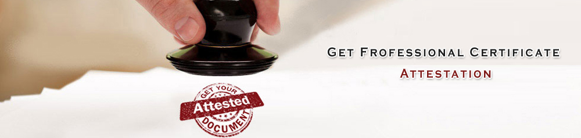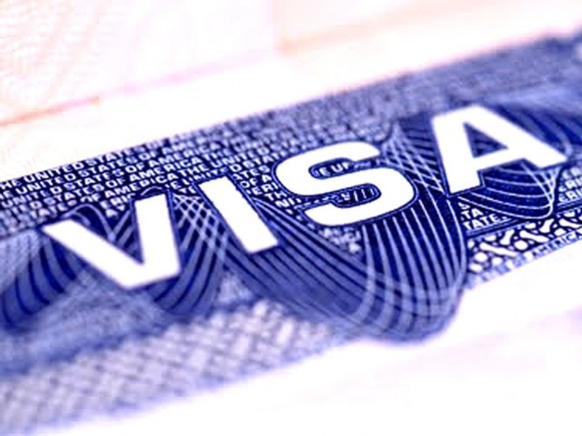
Welcome to Time2journey - Visas

At Time2Journey.Com (A unit of Anubhav Travels) we provide visa and passport services in the India, for people who are willing to travel to any country in the world. If you want to travel abroad for business or tourist purposes then our agency can arrange visas for all destinations that require an entry visa in a short period of time.

Time2Journey professional and dedicated team of visa specialists are wholly committed to provide efficient and professional passport and visa services. They will advice you at each step of the way by providing efficient and effective visa information and application service to private as well as commercial applicants. We have years of experience in the industry and have been collecting tourist and business visas on behalf of India travellers since 1997.Our experience and attention to detail has made many established travel agencies to win our trust. Therefore, we have achieved a preferred visa supplier status by leading travel companies in the India for providing professional services for both tourist and business visas, as compared to a large number of independent agencies.

Apart from offering specialist visa services we also provide document legalisation and passport renewal services from various foreign embassies in the India. Our specialist visa consultants will save you from the hassle of spending your time and effort in collecting the required documents and following the right procedure as you can rely on our expertise to carry all these functions and details with accuracy and precision.

In addition to all these services we can also assist you with the renewal of your Indian passport.

Document Legalisation

Time2journey VISA SERVICES offers fast, easy, and secure processing of document legalisation services.

Legalisation is the official process of document authentication granted by Indian governments. Each country has its own legalisation requirements which are determined by the type of document being legalised and its intended use. Your document must be legalised by both the India MEA (Ministry of External Affairs) and in many cases, also at the embassy of the foreign country in order for it to be considered genuine.
Documents requiring legalisation services can include:
- Academic Certificates
- Birth, Civil Partnership, and Marriage Certificates
- Business Contracts
- Certificates of Incorporation
- Certificate of No Impediment
- Documents from British Overseas Territories
- Export Certificates
- Religious Documents

TIME2JOURNEY VISA SERVICES can obtain document legalisations in as little as one day. We will collect your documents and submit them to the MEA and appropriate embassy on your behalf.

